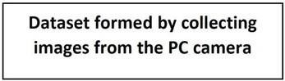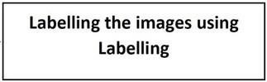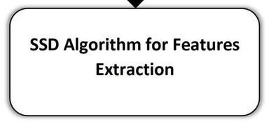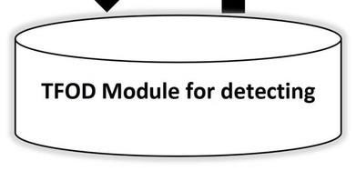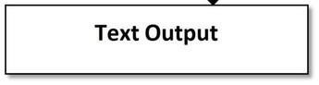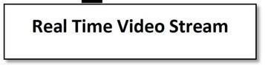

**Solution**

**Architecture**

Team

ID

PNT2022TMID08478

Project

Name

Real

-

Time

Communication

System

Powered

by

AI

for

Specially

Abled